Report Title | Councillor activity
Councillor Name | Spencer Nicholls
PC Meeting Date | Monday 12th January 2026
PC Meeting reference  (if known) | 26/011

 | 1 | My Activity.  With work and the time of the year it means there has been no specific PC activity on my part since the last meeting.
 | 2 | Chase the Joker  The Jackpot is slowly building and is now over £4,000 and so far we have raised approx. £1,500 for Chirpie Chicks. The last draw was 19th Dec 25 and will commence again on 16th Jan 26. This was done due to the altered opening times over Xmas.
3 |  | Events held  6th December – Tropics night held.  20th December – Christmas Tree Window unveiling and the kids Christmas Party. Over 30 children attended and the event a lot of fun for everyone who attended.
5 |  | Up Coming events  The club is closed until the 16th January.  Bingo will return in January. A special mention to Julie Powell and Terri Meechan who retired after running Bingo for 24 years. Thank you ladies.  The Dart league will reopen in Feb.  MacMillan Charity Darts – 1st Feb from 11am for a 12 hour Darts Marathon. £10 to enter with a buffet included. The target is £500 and so far £233 has been raised. Donations and players welcome on the day. Anyone who would like to be involved can turn up on the day. There will be darts available and any non members can be signed in.
6 |  | InPost  This highlights the usage for the first 9 weeks of the locker.  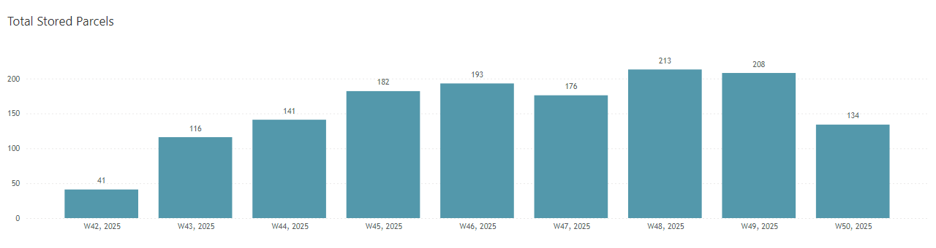  Its great to see the locker being used by so many people. For those that don’t know you can also send parcels to residential addresses aswell as businesses. So if you cannot make it to the Post Office this is a great alternative and is based on the size of the package.
7
8
Report Title | Community Report
Councillor Name | Gary Freegard
PC Meeting Date | 12 January 2026
PC Meeting reference  (if known) | 26/011

Item no. | Report
1 | Funday 2026  - I have started to gain sponsorship for the event, Lawson of Corby have agreed to be one of the sponsors. I’m also looking into getting a mobile stage for this year. Corby radio have also shown an interest.
2 | Muga  - I’ve been looking into ways to make more of an income from the Muga, including sponsorship boards around the fencing.  - I’m looking at grants to get the pitch updated as well as new goals and netting.  - Plus trying to arrange an up-to-date booking system.
3 | Website  - The website is proving a difficult situation as the system is not one that I’m used to, I had access issues which I have now rectified.  - I’m hoping to have it up and running within 6 weeks

Report Title | Community Report
Councillor Name | Susan Husk
PC Meeting Date | 12 January 2026
PC Meeting reference  (if known) | 26/011

Item no. | Report
1 | School  - Nothing to report.
2 | Bus Service  - Prior to Christmas the RF1 Info Bus was parked outside the Corby Cube and David Fursdon took the opportunity to speak to staff present, as well as the NCC Public Transport Officer, and suggested bringing the bus to the village, perhaps to coincide with a Village Hall lunch to promote the service further amongst residents. They will consider this idea, and David will let me know if he hears anything further. If this happens, GPC attendance might be appropriate also.
3 | Doctor’s Surgery  - Nothing to report.

