Report Title | Community Report
Councillor Name | Susan Husk
PC Meeting Date | 11 May 2026
PC Meeting reference  (if known) | 26/165

Item no. | Report
1 | School  - I maintain regular contact with the school; nothing to raise at this time.
2 | Bus Service  - I’ve been in regular touch with Blands who operate the Rutlander Bus Service and Lawson’s Bus regarding the recent road closure along the High Street to the Kirby Road junction. This closure was scheduled for three days but actually just took one day which enabled normal service to resume quicker than anticipated.  - A further road closure is scheduled along the High Street for three days from 1 June; this will again affect the bus service so I will be contacting the bus companies in due course.
3 | Doctor’s Surgery  - Nothing to report.
4 | Pocket Park  - Tree survey undertaken 22 April 2026.
5 | Gretton Nature Recovery Group  I share below an update which Jacki Lilley has kindly provided:  - Ian and Sara attended the first LNRS meeting in April. Update to be given at our May meeting.  - The Swift Street event was held at the village hall on 12th April. The group were happy with the attendance and encouragement received from residents (and non-residents). After the meeting, two more workshops were completed to make swift boxes for those who were unable to attend on the 12th. To date, 40 swift boxes have been made - 32 using the materials supplied by the Parish Council and a further 8 using materials supplied by a builder who sponsored the purchase of the wood. A group of volunteers have been helping to erect the swift boxes on houses for those unable to do it themselves. The swifts should be arriving soon, so fingers crossed they find the new boxes.  - We have applied for funding from the National Lottery for the Nature and History Trail. We should hear as to whether or not our application has been successful by the end of July.  - The next CAN Champion meeting is in May.  - The Community Orchard is still waiting to hear if they will be granted funds from the Members' Empowerment Fund for the additions to be made to the orchard.  I plan to attend the next Nature Recovery Group on 13 May.
6 | Gretton Community Orchard  - As PC contact, I am on the mailing list to receive a copy of the minutes of the GCO meetings; most recent set have also been circulated to all Councillors by the Clerk.  - Their next meeting is 21 May at 7.30 pm.
7 | Public Memorials on Parish Council Land  - I took an action at the last meeting to establish the views of the Pocket Park and the Community Orchard regarding the above.  - Pocket Park – discussed at their recent meeting; there are sufficient benches currently and trees planted in memory of loved ones. Nothing further required at this time.  - Community Orchard – view is that there are sufficient benches and more would cause issues with regard to grass cutting. The Chairman also shared that the trees in the orchard were planted by and on behalf of individuals/families in the community and in some cases in memory of loved ones. They would not wish for any memorials to be added to the area for the time being.
8 | During April I have also represented GPC at the meeting convened between the Football, Cricket and Rounders Teams, and the Annual Parish Meeting.
Report Title | Parish Council Meeting Report
Councillor Name | Fraser Wright
PC Meeting Date | 11th May 2026
PC Meeting reference  (if known) | 26/165

Item no. | Report
1 | Annual Parish Meeting – 24th April  Many thanks to Councillor Husk for assisting at the Annual Parish Meeting. In total  12 community groups gave reports on their activities. The minutes for the meeting  have now been posted on the PC website.  During the Q&A section the meeting discussed that changing the scheduling may  improve attendance. Since the meeting the legislative requirements have been  clarified, the meeting must be held at a time after 6pm but there is no stipulation that it  must be held on a weekday, in future the Council may wish to consider scheduling for  a Saturday or Sunday to combine the meeting with a wider Community Day.
2 | Finance Committee  At the meeting of 21st April the Committee reviewed of year-end finance report for  25/26 and discussed the arrangements for the internal audit and AGAR report.  The Finance Committee have also received and reviewed a draft lease document for  Gretton Sports & Social Club. This has now been shared with all councillors for their  review.
3 | FOI Request to NNC for Drainage Gully Locations and maintenance schedule  Following an inadequate response to Cllr McDonald’s Member Enquiry concerning  drainage plans for then village I have submitted a Freedom of Information request to  NNC (Reference 202601050). The requests ask for the following:​  ​  1. The location of highway gullies and road drains, as held in asset registers, maps, or  GIS datasets.  2. The date each asset was most recently inspected.  3. Details of maintenance works undertaken on these assets in the last three years,  including the type of work and the date carried out.  4. The date of the next scheduled or planned inspection for each asset, or the standard  inspection frequency applied where individual dates are not recorded.  NNC have until Monday, May 18th to respond to the FOI request.
4 | Community Orchard AGM – 16th April  Attended on behalf of the Council. The opportunity was taken to discuss with the  group their opinions on requests for memorial benches to be placed in the Orchard.  Their opinion at this time is that there is sufficient seating available in the orchard and

that they no need for additional benches. They would be happy to review again in
future.

Also advised the group of recent media reports concerning proposed changes to the
NNC ward empowerment fund, alternative sources of funding for projects may be
required in future.

5 | Meeting of Recreation Ground Users – 22nd April  Meeting to discuss clashes of use was held on 22 April. Notes of the meeting have  been shared with councillors.  WhatsApp group now established and being used to good effect to manage use of the  field.
6 | Tree Survey  On the morning of Wednesday 22nd April I met with Rebecca Peace who conducted  the Tree Survey of parish managed sites.  Advice was sought on the management of the Yew Trees in the Paddock Park,  Rebecca advised that any tree surgeon would be familiar with handling yew and would  be able to manage the safe disposal of cuttings. If the group wish undertake this work  themselves then it would also be fine to dispose of the cuttings into a green waste skip.  Advice was also sought on appropriate replacements for gaps in the tree line at the  Recreation Ground and regarding the subsidence report at Picks Playing Fields.  Details of this have been covered in the report.
7 | Website  Following report of an image subject to Copyright being present on the website a  review of each page was undertaken and any images with unknown provenance have  now been removed, similarly all back issues of Gretton Life have been removed from  the website.

Report Title | Councillor activity
Councillor Name | Gary Freegard
PC Meeting Date | Monday 11th May 2026
PC Meeting reference
(if known)

Item  no. | Report
1 | Hunts Field Drive – MTHV  I have spoken to MTHV regarding the private access signage, as there has been no  communication or updates from MTHV regarding this matter. I am waiting ti hear back from  the repairs Manager to discuss options later this week.
2 | Parish Council Training  I attended my Finance training on the 28th April
3 | Funday Monthly Progress Report  This month, significant progress has been made in preparation for the Funday event:  ∙Private Seller Pitches: The majority of private seller pitches have been sorted, with  only 6 remaining available.  ∙Catering Vendors: All catering vendors have been successfully confirmed.  ∙Charity and Community Groups: Most stalls for charity and community groups have  been confirmed.  ∙Raffle Prizes: 6 out of the 12 raffle prizes have been sourced.  ∙Marketing Materials: Work is underway to organize flyers, posters, and banners. The  process is pending the issuance of the PC debit card to proceed further.  Overall, preparations are on track with key elements nearing completion.
4 | Community Engagement  I’ve been in communication with our PCSO Ali and Lydia’s setting up a monthly meeting to  engage with the community. Im awaiting feedback from Lydia’s before I continue
5 | Verge mowing  As most are aware we had a comment and message on our Facebook page from a resident  complaining about NNC not completing the verge mowing around the village.  Fraser kindly sent me the mow map to look over.  I contacted NNC Highways and I was informed that works should be completed in 5 working  days, as this has still not been completed I will be getting back in contact with NNC
6 | Recreation Ground  I also represented GPC alongside Fraser, Susan and Caroline at the meeting between the  Football, Cricket and Rounders Teams.

During this meeting the Muga surface was also discussed and how if the surface was changed
more local sports groups (Including Football and rounders) would use it. I am looking into this.

Report Title: Parish Council Meeting Report
Councillor Name: Caroline Curtis
PC Meeting Date: 11/05/26

1 – Community groups sharing of the Recreation Ground - Attended meeting on the 22/04/26
regarding the fair co – ordination of the use of the recreation ground for various community groups
who regularly use the space. Outcome achieved with a new WhatsApp group in place to ensure any
future training sessions and fixtures are positively communicated between all concerned and managed
between all parties. This has begun and is to date working successfully.
2 – Polite Parking Banners - Now collected ready to be placed at appropriate places around the
recreation ground. The invoice has been paid.
Report Title | Councillor activity
Councillor Name | Spencer Nicholls
PC Meeting Date | Monday 11th May 2026
PC Meeting reference  (if known) | 26/165

1 | My Activity.  I conducted the inspection of the points raised in the Annual Inspection  of the Muga, Skate Park and Gym equipment with Steve Ellis. Steve and I  went through each point and made the relevant alterations where we  could. The Gym equipment will need to have its points serviced by the  gym company.  There are no existing matters of concern.  I met with another company for the upkeep of the Play Area. His  comments were that we have excellent facilities that lots of villages or  towns would be proud of. The equipment is all good and he wouldn’t  recommend changing any. The flooring is the issue and in his opinion it  is expensive but this will be well worth the investment if we can get a  grant as it will provide an excellent facility for years to come. I asked  about the upkeep and whether we could form a working group and he  thought this was ideal. He could refurbish the equipment but this would  be at a cost.  Steve and I fixed 4 posts on Huntsfield. I have submitted this in a  separate report along with my recommendation to purchase more repair  posts so we can fix the fence before it breaks in sections.
2 | Opening Hours  The Club is now open 7 days a week. With the recent warm weather its  been great to see all ages using the rec ground and cricket, football and  rounders have all brought the field alive.
3 | Whats on  Bingo every Monday  Day Disco – Saturday 9th May.  Darts – United for Max 30th May  Sponsors and Players still welcome.  Chase the Joker – Every Friday
4 | Last Month  Gretton Football Race Night – 25th April – A great night with nearly  £2,000 raised for the Football Clubs presentation.  George Boon Skittles – Well done to Alex Mason for winning our annual  competition.  Gretton Darts Winter League – This seasons winners were the club.  We have a new league starting in June, so if youd like to play get in  touch.

 | Skills Café – Watch out for the next one.
5 | Chase the Joker  The Jackpot is now over £1,000. Every Friday Tickets on sale 7pm til  8.30pm  Raising funds for local causes.

6 | Working Day  Id like to propose and organise a working day for the play area.  The swings could do with a rub down and paint.  The dinosaur – the wood has started to wear , this needs sanding and  painting.  There are other parts that could do with a clean , some oil for lubrication  and just some general TLC. It would be great to get a working group of  volunteers to spend a day giving our play area some attention so its  continues to stay in such good condition.  I would photograph the areas that we need to tackle and ask for  volunteers to help.

Report Title | Update on work completed the fencing at the Rec Ground
Councillor Name | Spencer Nicholls
PC Meeting Date | Monday 11th May 2026
PC Meeting reference  (if known) | 26/164

1 | My Activity.  Steve Ellis and I met and used the 4 metal fence posts to repair a section  of the fence. We chose the entrance by the park, and the section by the  gap just beyond the dirt track. The metal poles worked well and as the  pictures show they have helped make the fence more sturdy without  having to concrete additional posts in which would cost more.
2 | Next Stage  There are 82 posts on the fence.  We have fixed 4 and 13 more need to be fixed.  I would ask that we buy 13 more , or 16 if they come in packs of 4 and  Steve and I will fix these.  It would also be prudent to budget for 8 or 12 a year to then add these to  other posts before they become broken.  The same system could also be used at Church Gap.

Report Title | Update on work completed the fencing at the Rec Ground
Councillor Name | Spencer Nicholls
PC Meeting Date | Monday 11th May 2026
PC Meeting reference  (if known) | 26/164

1 | My Activity.  Steve Ellis and I met and used the 4 metal fence posts to repair a section  of the fence. We chose the entrance by the park, and the section by the  gap just beyond the dirt track. The metal poles worked well and as the  pictures show they have helped make the fence more sturdy without  having to concrete additional posts in which would cost more.
2 | Next Stage  There are 82 posts on the fence.  We have fixed 4 and 13 more need to be fixed.  I would ask that we buy 13 more , or 16 if they come in packs of 4 and  Steve and I will fix these.  It would also be prudent to budget for 8 or 12 a year to then add these to  other posts before they become broken.  The same system could also be used at Church Gap.

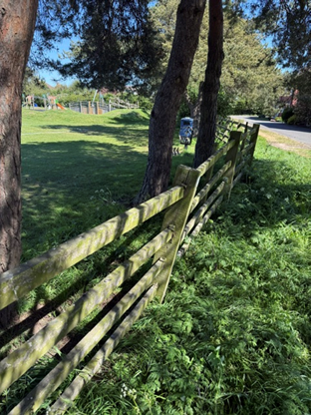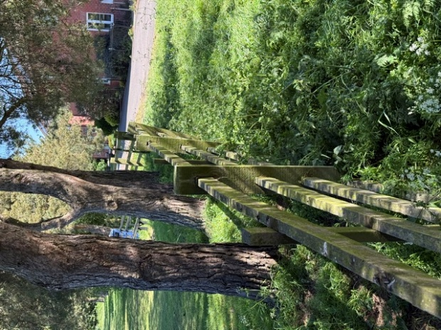
Before After
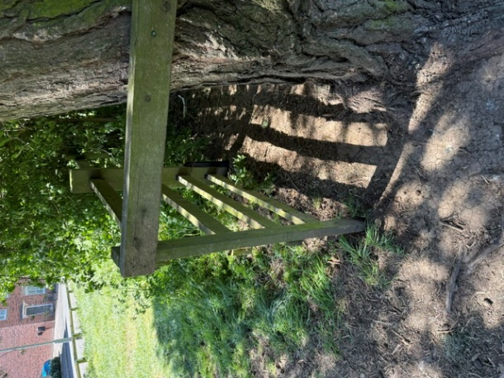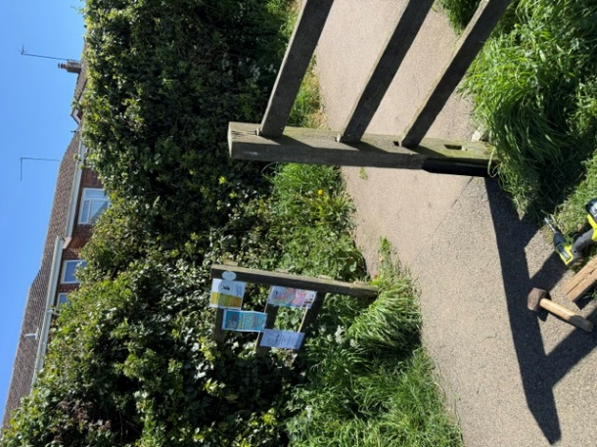
Only right hand side fixed

