Speed Report Jan 1st to March 31st 2026
Corby Road Arriving
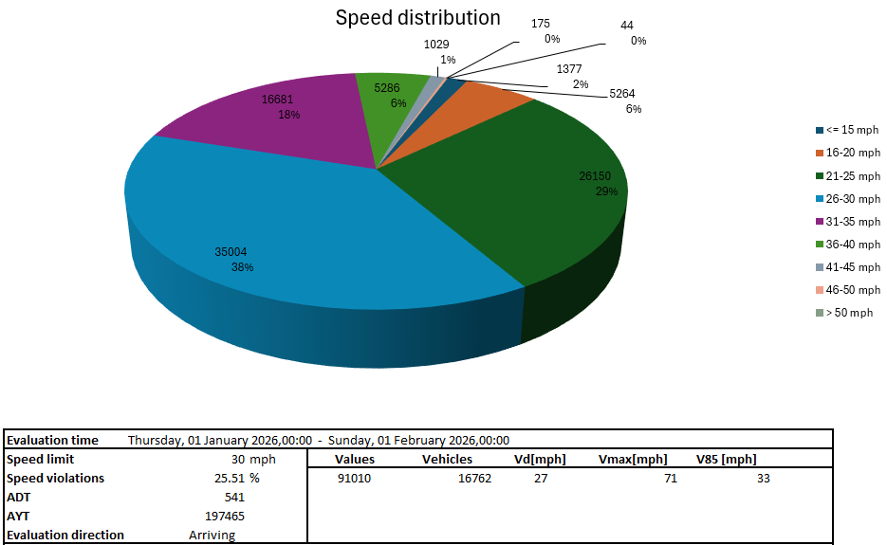
January

February
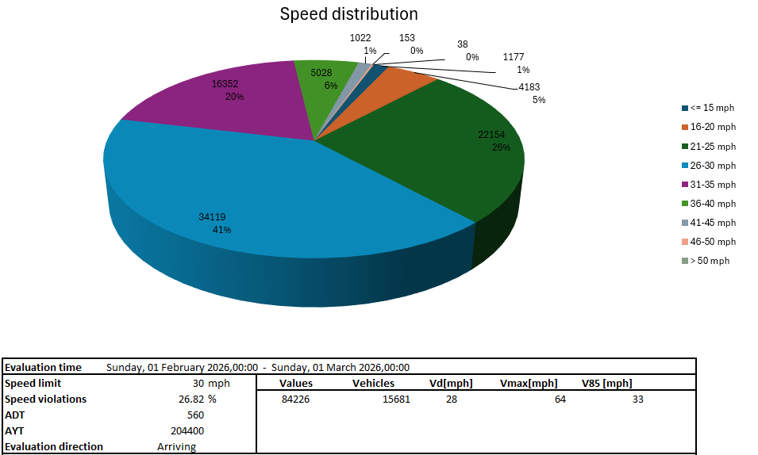

March
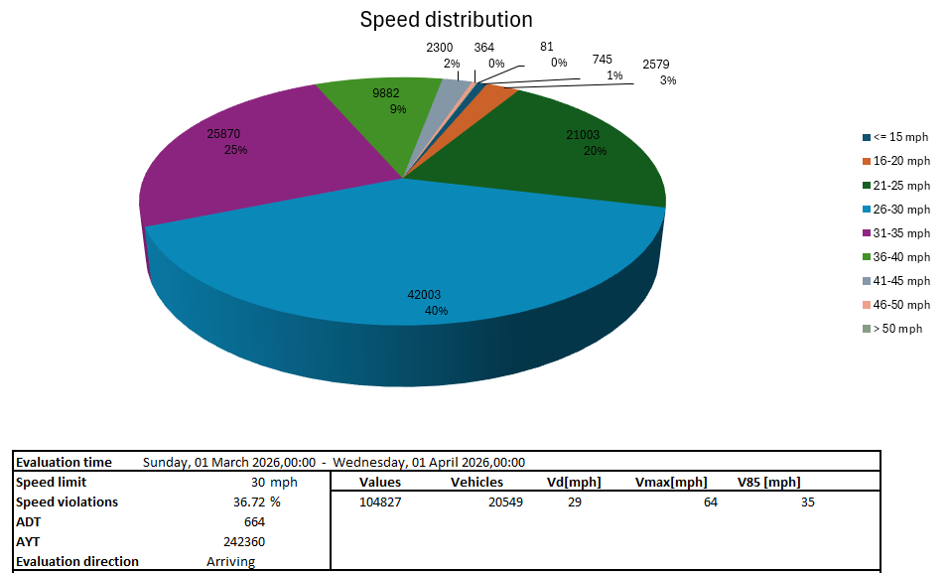
Corby Road Departing
January
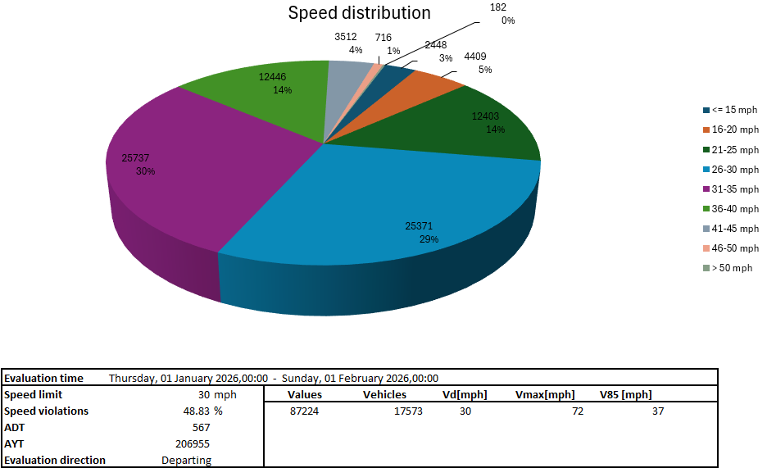

February
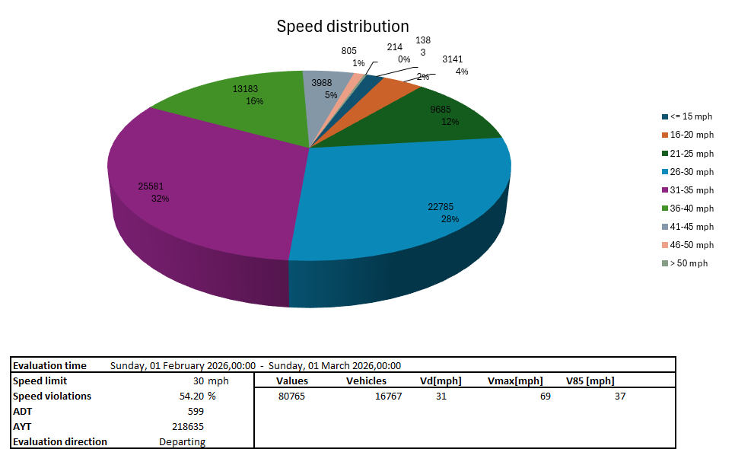

March
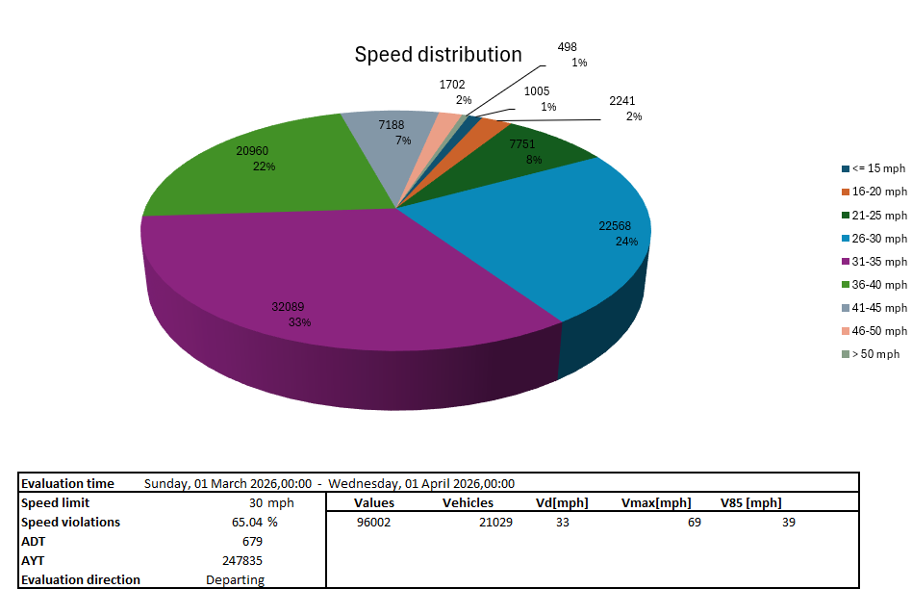
Harringworth Road Arriving
January
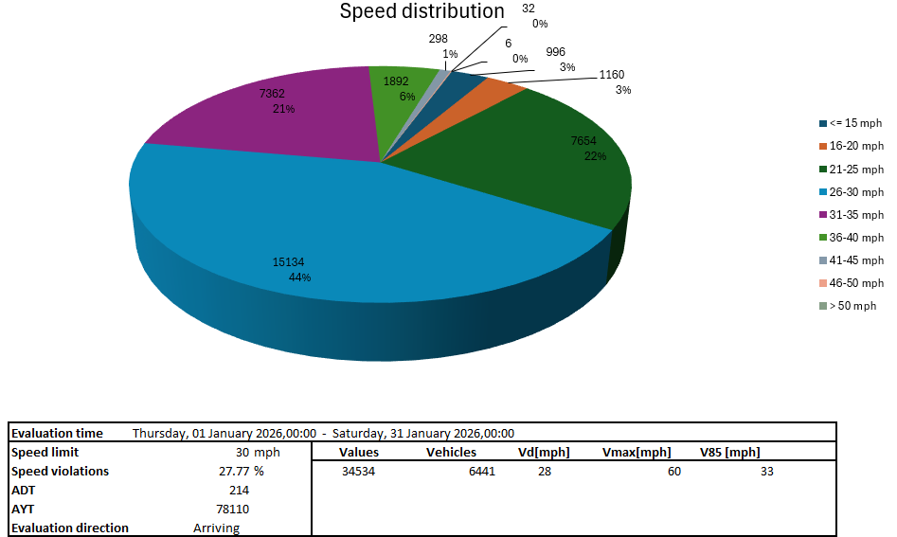

February
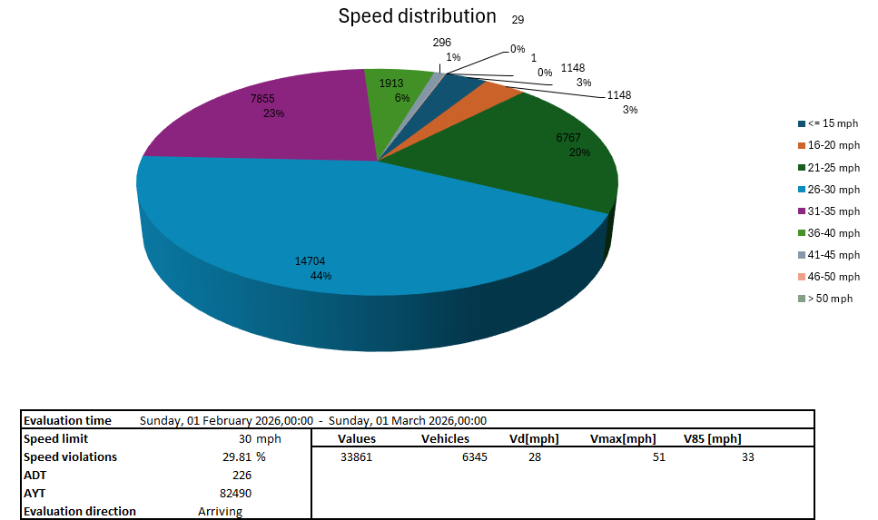

March
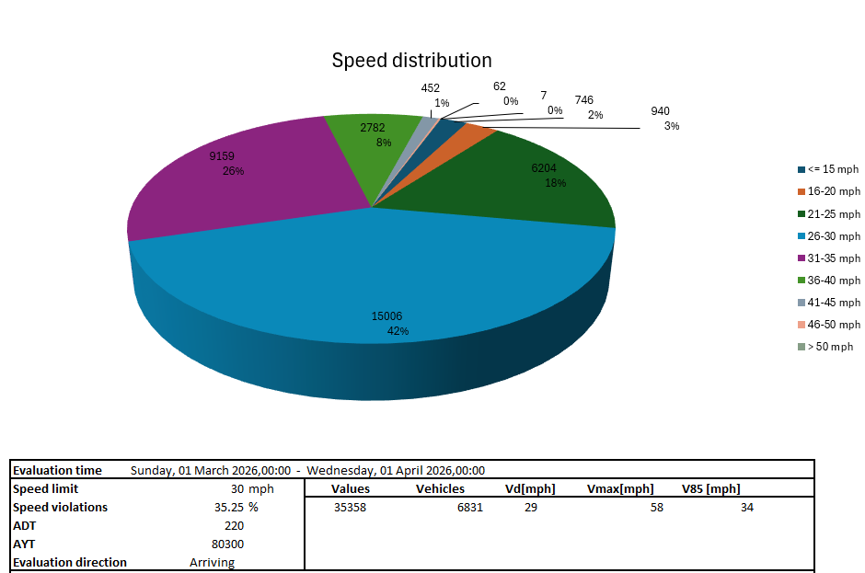
Harringworth Road Departing
January
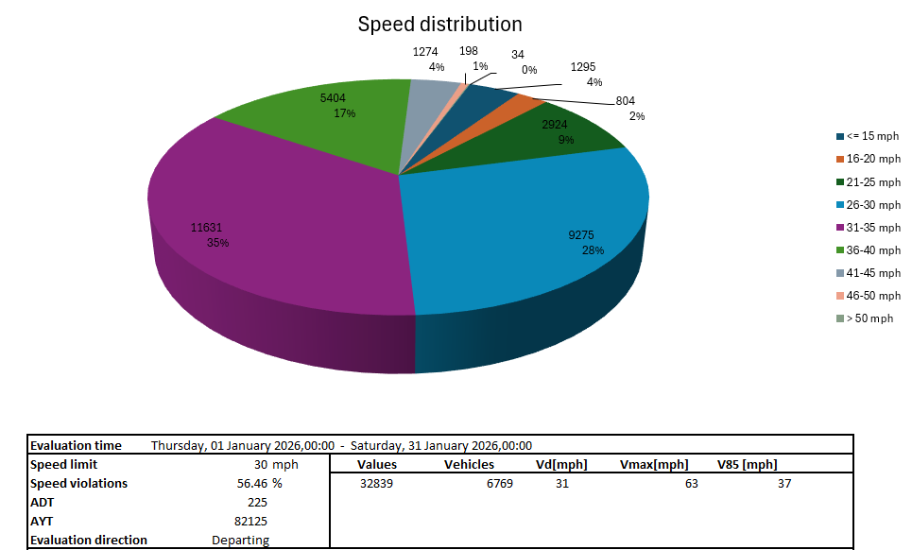

February
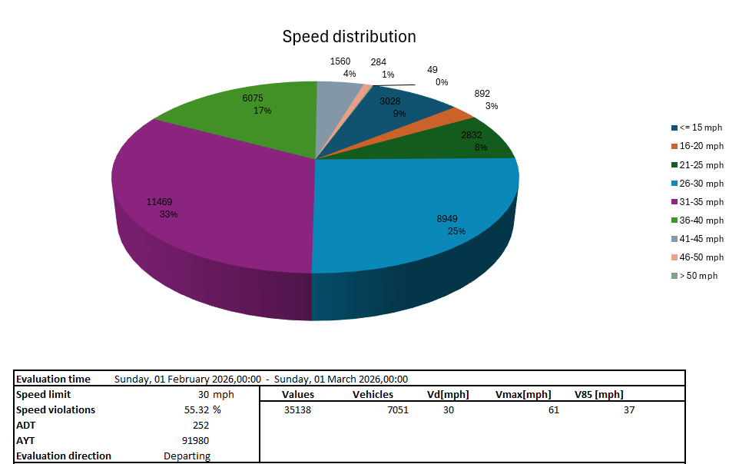

March
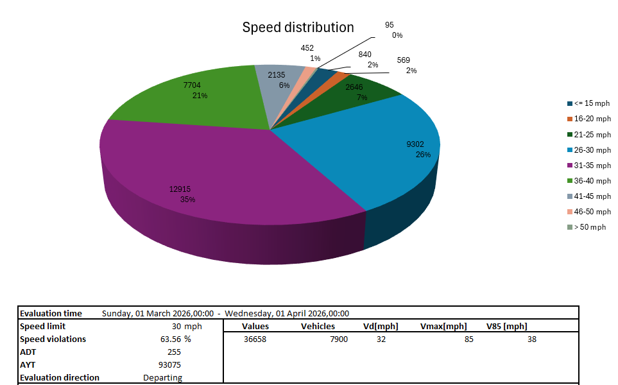
Lyddington Road Arriving
January
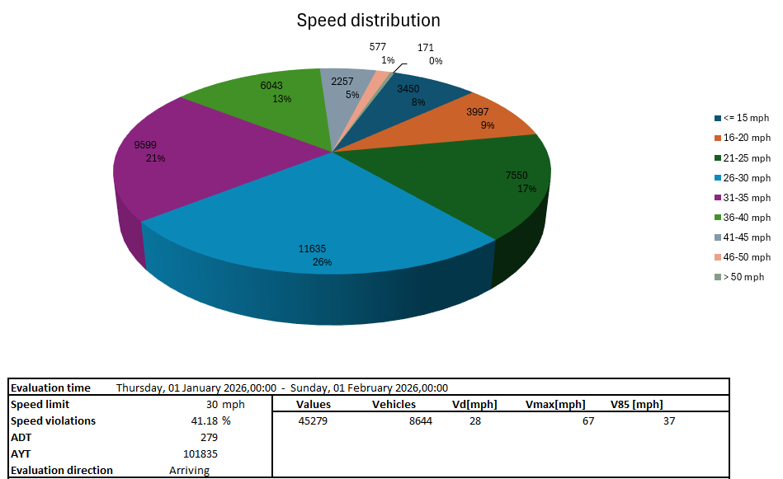

February
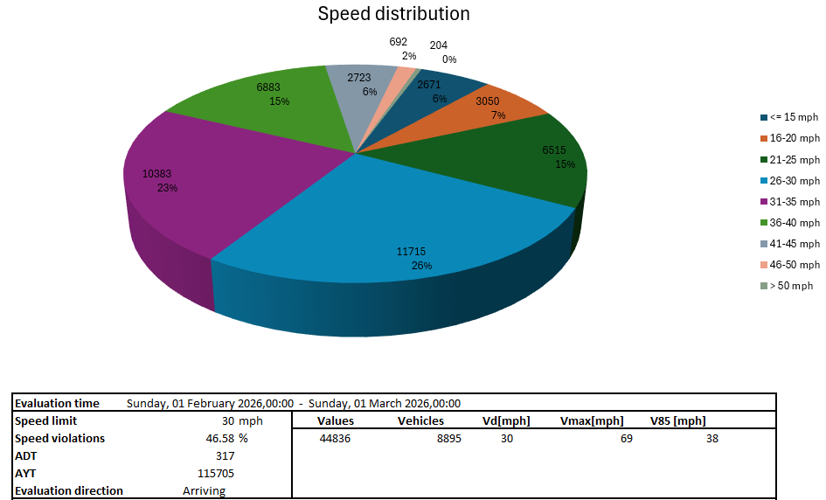

March
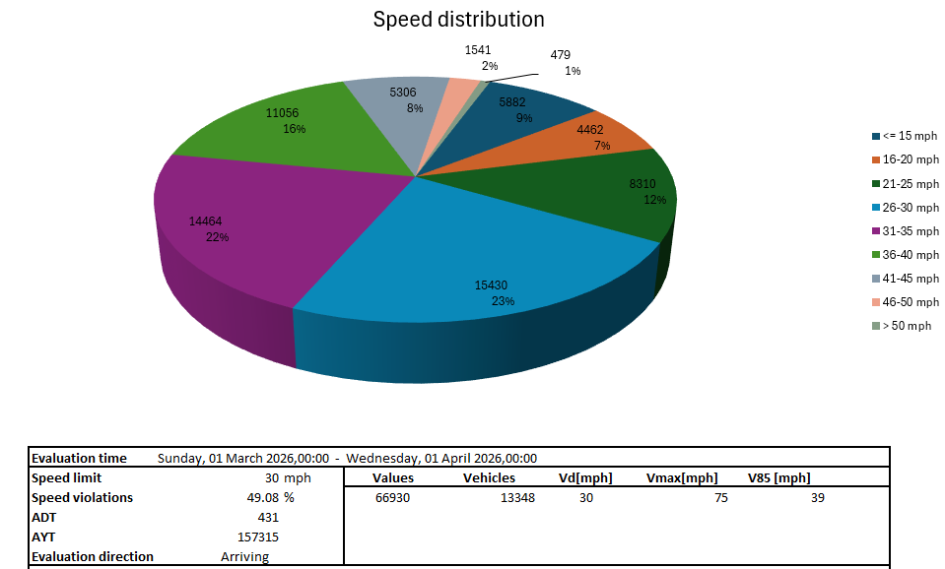
Lyddington Road Departing
January
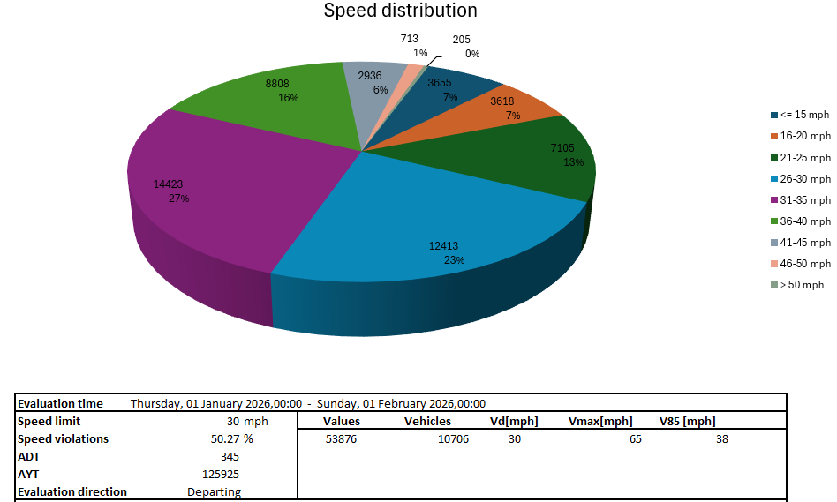

February
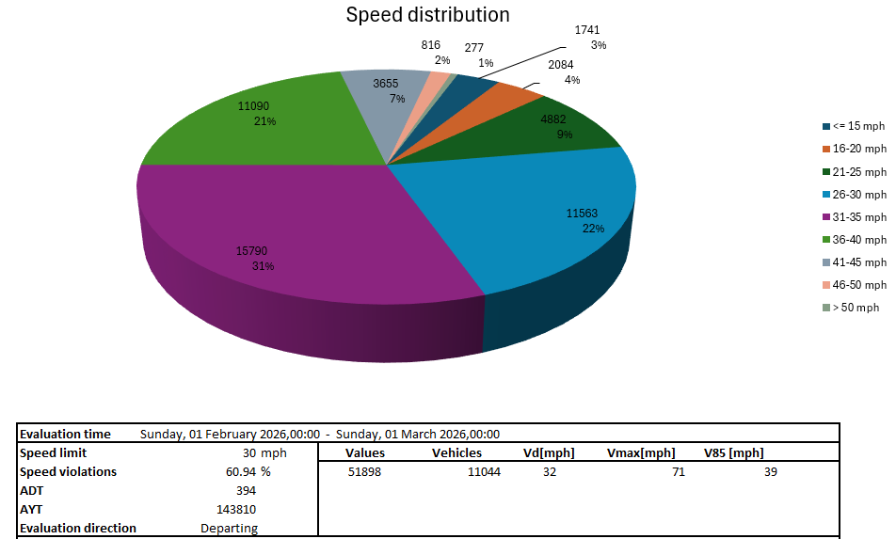

March
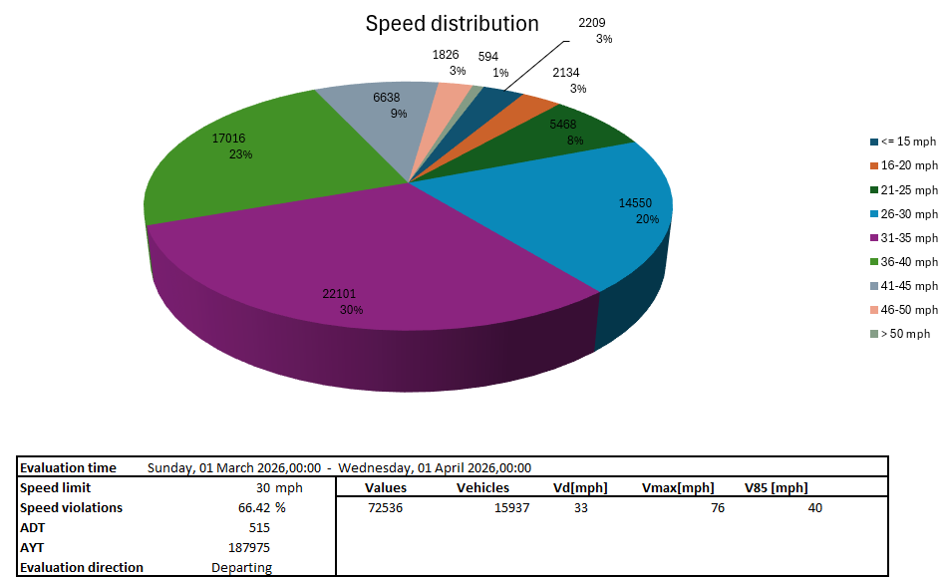
Summary of Report
Corby Road
Vmean arriving is at 27-29mph and departing at 30-33mph.
V85 arriving is at 33-35mph and departing at 37-39mph.
Vmax speeds are at or above 64mph, the highest reading is 72mph.

Harringworth Road
Vmean arriving is at 28-29mph and departing at 30-32mph.
V85 arriving is at 33-34mph and departing at 37-38mph.
Vmax speeds are at or above 51mph, the highest reading is 85mph.

Lyddington Road
Vmean arriving is at 28-30mph and departing at 30-33mph.
V85 arriving is at 37-39mph and departing at 38-40mph.
Vmax speeds are at or above 65mph, the highest reading is 76mph.

Of note:
Corby Road – Overall, very similar readings to the previous quarter, the February and March readings are slightly lower than January. I think this change is not significant.
Harringworth Road – As with Corby Road, very similar to last quarter with slightly lower reading in the last two months. I think this change is not significant.
Lyddington Road- The overall figures are similar, however, even though the maximum speeds recorded are still very high, some maximum speeds have been almost 10mph lower than the previous quarter. Has the direct appeal to the village through the parish magazine had a small impact?

